Azure Storage Accounts

## **1. Creating New Azure Storage Account**

To create a new Azure storage account, the steps mentioned below need to be followed.

1. Go to Storage accounts from Microsoft Azure portal.

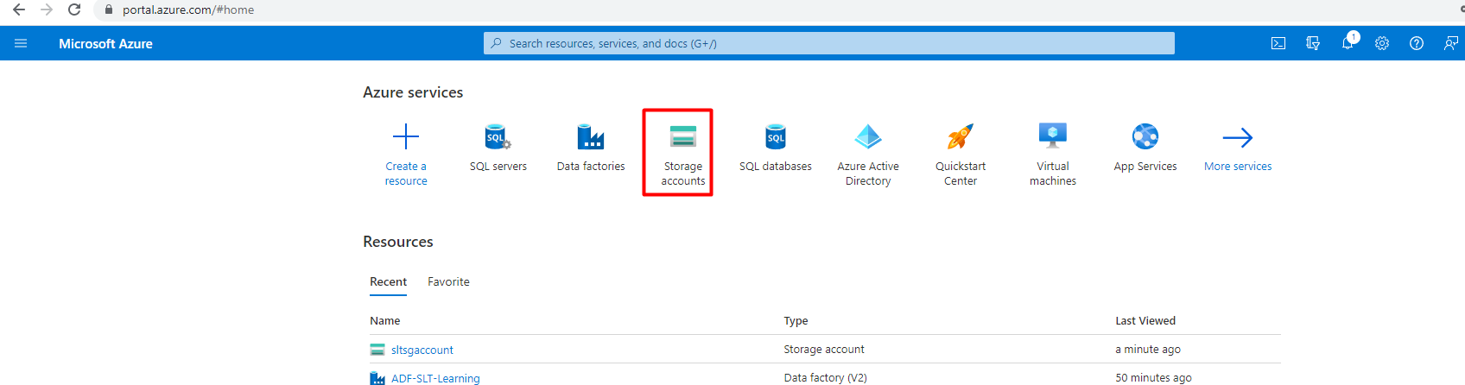

1. Go to Create icon at the left corner of the page.

1. Fill in the suitable account name. Modify other options as per the requirements.

1. After reviewing all the details, click on create. A new storage account will be created.

# **2. Uploading files in Storage Account**

To upload the files in the storage account,

1. Go to the Storage accounts and choose the required storage account.

1. Go to Containers from the storage account Overview page.

1. Click on container icon in the left corner and give a suitable name to the container

1. To upload the files, click on Upload in the left corner

1. In the Upload blob pane, choose the required files from local system to bring to the azure storage and fill in other details in the advanced option. Click on upload at the bottom of the pane.

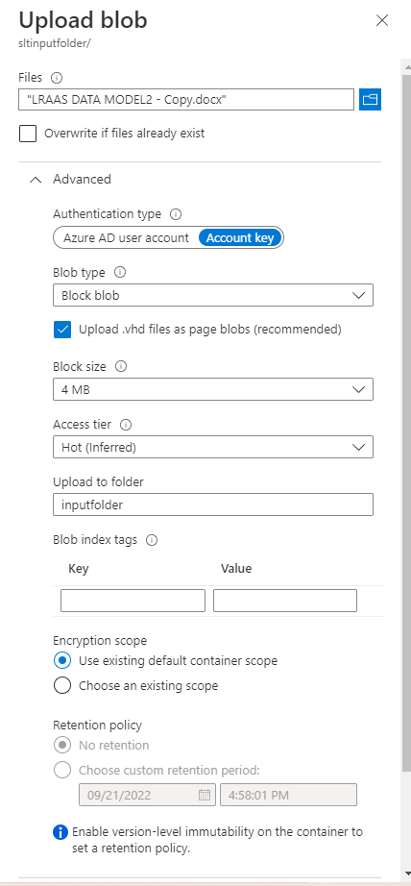

Files will be successfully uploaded to the Azure Storage account.